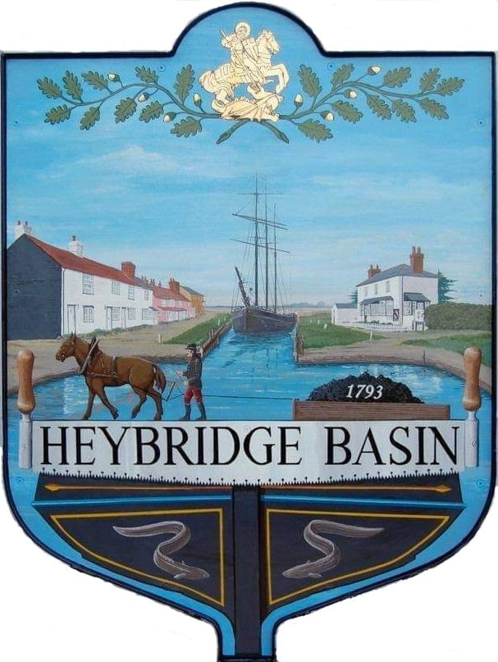

HEYBRIDGE BASIN PARISH COUNCIL

Minutes of the Full Council meeting of Heybridge Basin Parish Council held on Tuesday 23rd April 2024 at 07:30pm, at The Lock Tearoom.

PRESENT

In the Chair: M. Hodges (Chair) Absent: 0

Councillors: R. Bryson (Vice Chair) Apologies: 1
C. Edmond
M. Hobden Public: 3
J. Sjollema
C. Swann Officers: G. Lake – Clerk

It was noted that this meeting was being recorded by the Clerk.
The meeting commenced at 07:39pm due to the Annual Parish Assembly overrunning.

23/239 Chair’s Welcome
Cllr Hodges welcomed everyone to the meeting.

23/240 Apologies for Absence.
Cllr Howat.

23/241 To receive Declarations of Interest in accordance with the Council’s Code of Conduct and with section 106 of the Local Government Finance Act 1992.
C. Edmond – Non-Pecuniary – Essex Waterways and Director of Cloughton Court Management Company Ltd and Cllr Hobden – Non-Pecuniary – HBSA, Basin Oars and HB River care and Cllr Swann - Non-Pecuniary -Owner of Tearoom building.

23/242 To sign as a correct record the minutes of the full council meeting held on 12th March 2024.
The Minutes as previously circulated were agreed as a correct record.

23/243 To sign as a correct record the minutes of the extraordinary meeting held on 3rd April 2024.
The Minutes as previously circulated were agreed as a correct record.

23/244 To receive a report from the District and County Councillors for the area on any matters of interest.
A report was received from the District Councillors during the Annual Parish Assembly.

23/245 Finance.
- To approve
- Payment requests for March/April 2024
The Payments as previously circulated were approved with the exception of withholding the payment to Scribe until the reporting error has been resolved.
- Receipts for March/April 2024
The receipts as previously circulated were approved.

23/246 Planning Applications
- To consider any planning applications received after the publication of the agenda and to agree the action to be taken.

24/00183/FUL – Leanna House, Lock Hill – Part demolition existing workshop; two storey side extension, raising of roof and conversion to residential dwelling with ground floor garage below. – To clarify the previous resolution and agree any action to be taken.

The Parish Council had received some new information since their previous resolution and resolved to defer this item until the May meeting.

23/247 Daisy Meadow Car Park
- To receive an update from the Working Group and agree any action to be taken.
Due to the current damage to the first wall in front of Rohan House, Camway have advised that it is not viable to erect a fence in front of it, and that the fencing will now commence from the second wall and will now be 5ft high to prevent a tunnelling effect.

On Friday 12th March, a damaged sewage pipe was unearthed. Anglian Water were called to site and fixed the issue, however this did result in a £180.00 charge from Camway, as they required a supervisor on site during the repair as they owned the trench the pipe was in.

A quote was sought from Camway to repair 2 areas within the main car park site.
It was resolved to reject the quotation and seek multiple quotes later in the year as this was not a priority.

- To review the planting plan proposal from Cllr Hobden and agree any action to be taken.
A planting plan had previously been circulated to all members. It was resolved to accept phases one and two of the proposal, excluding purchasing bulbs. It was resolved to check the bio-diversity policy prior to using any chemical sprays to de-weed the raised bed.

23/248 Turning Post
  - To review the Turning Post Policy and documentation from Essex Waterways and agree any action to be taken.
It was resolved to accept the licence agreement from Essex Waterways with the recommended amendments.
It was resolved for members to send their comments regarding the Turning Post Policy to Cllr Hobden ready for discussion at the May meeting.
Cllr Edmond abstained from discussions and the votes due to his non-pecuniary interest.

23/249 Goal Posts/Basketball hoops
- To receive an update from the Clerk and agree any action to be taken.
The Clerk informed members that MDC were looking into whether match funding was still available, however MDC were not able to offer an inspection service or insure the equipment as the property would belong to HBPC. It was resolved for the Clerk to check the Council’s insurance as to whether the equipment would be covered under the current policy. It was resolved for the Clerk to research inspection options.

23/250 Clerks Report
- CiLCA – The Clerk informed members that she had completed and passed her CiLCA qualification at the end of March and for members to note that the pay scale 24 applied from 1st April 2024 and that the Council would be able to adopt the General Power of Competence at the next meeting.
- VDS Survey - The Clerk advised that the Village Design Statement survey had been distributed to all residents and was also active online.
- Audits – The Clerk informed members that that the Internal Audit was taking place on 22nd May 2024, and that the Council would need to allow time for the Clerk to prepare for this as well as the required year end/external audit tasks.

23/251 Correspondence
- To note correspondence received and any actions to be taken.
Correspondence was noted and responses were agreed.
It was resolved to donate £200.00 to the Defib Fund. Cllr Bryson declared a non-pecuniary interest and abstained from the vote.

There being no further business the meeting closed at 08:37pm
Provisional Date of the next Council Meeting Monday 20th May 2024

Clerk Contact details: clerk@heybridgebasinpc.org.uk
Website: www.heybridgebasin-pc.gov.uk

